 | School of Engineering & Technology
 | Department: SOET | Session: 25-26 Even
 | Program: B. Tech CSE | Semester: IV
 | Course Code: ENCS254 | Name: Vandana Sharma  Roll No: 2401010285
 | Course Name: Database Management Systems Lab | Faculty: Ms. Mansi kajal

Lab Sheet: 2

Objective:
• To understand and implement SQL transactions using COMMIT, SAVEPOINT, and ROLLBACK, retrieve records using SELECT queries, and perform INSERT, UPDATE, and ALTER operations on tables.

Instructions:
- Open your preferred Database Management System (DBMS) tool.
- Create the required tables: CLASS, EMPLOYEES, and Client_master.
- Insert the given/suitable records into each table.
- Execute the SQL scripts and queries step by step.
- Observe the output carefully after each operation, especially after ROLLBACK and UPDATE commands.

Table Structures:

CLASS
D (NUMBER) and Name (VARCHAR).
The initial records in the table are (1, 'Bravo'), (2, 'Alex'), and (4, 'Cheng').
DDL Questions (Data Definition Language):

- How do you create a table named CLASS with appropriate data types?
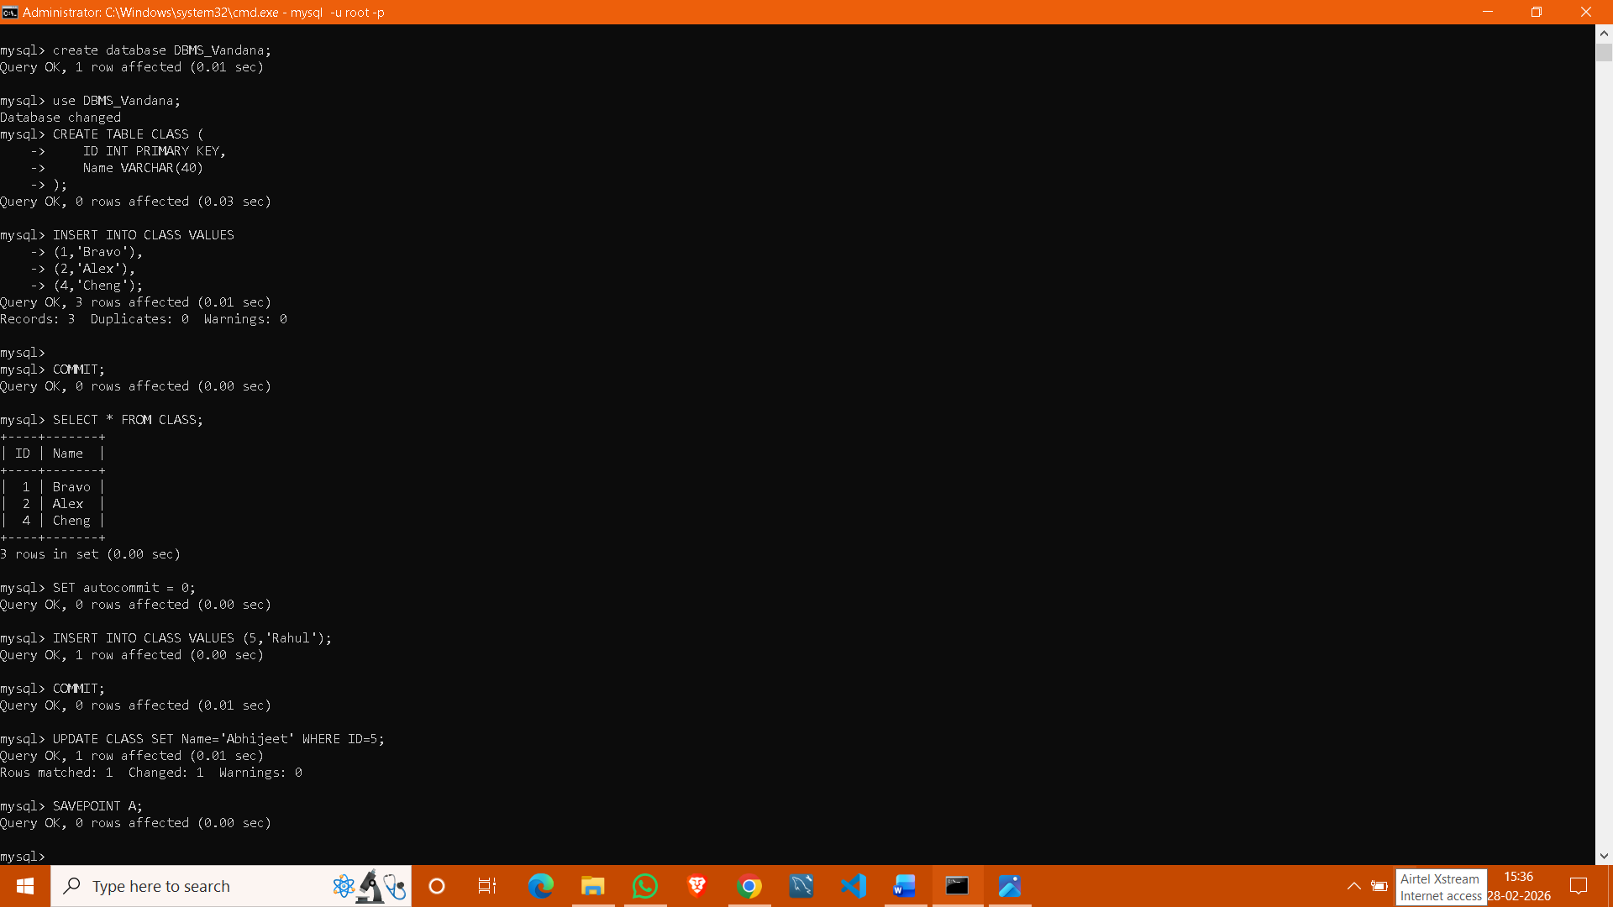
- How do you create a table named EMPLOYEES with the specified attributes?
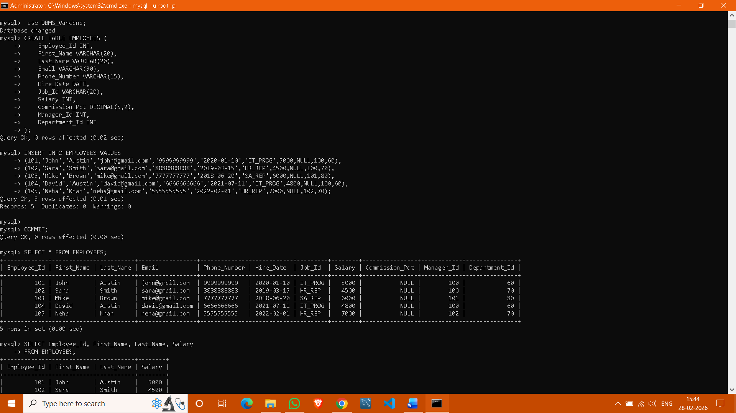

- How do you create a table named Client_master with the specified attributes?
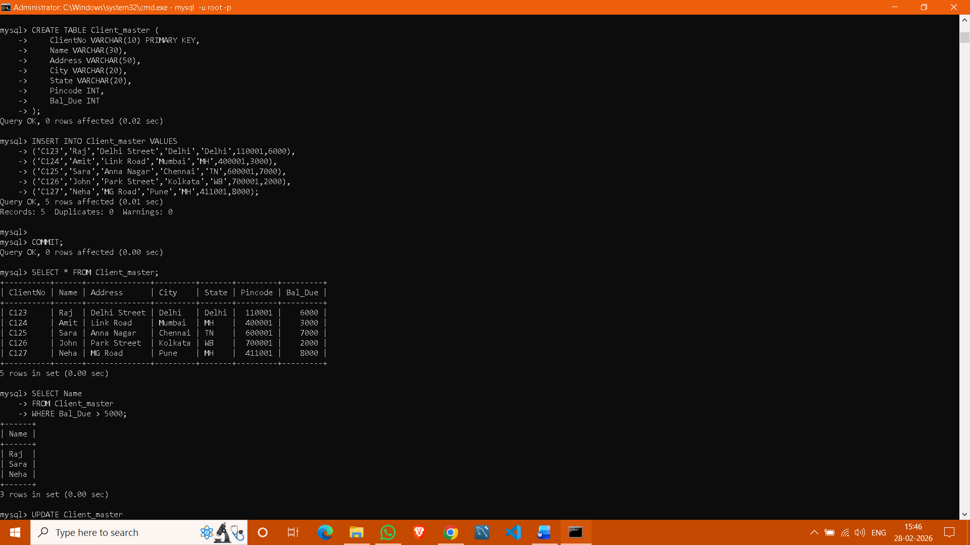

4.What SQL statement would you use to rename the table Client_master to Client12?
Ans: RENAME TABLE Client_master TO Client12;

5.How do you display the bal_due column heading as “BALANCE”?
Ans: SELECT Bal_Due AS BALANCE
FROM Client_master;

DML Questions (Data Manipulation Language):

Part A: Transactions and Savepoints (CLASS Table)
Give the output of the following SQL script:
  - INSERT INTO class VALUES (5,’Rahul’);
  - COMMIT;
  - UPDATE class SET name = ‘Abhijeet’ WHERE id=’5’;
  - SAVEPOINT A;
  - INSERT INTO class VALUES (6,’Chris’);
  - SAVEPOINT B;
  - INSERT INTO class VALUES (7,’Bravo’);
  - SAVEPOINT C;
  - SELECT * FROM class;
  - ROLLBACK TO B;
  - SELECT * FROM class;
  - ROLLBACK TO A;



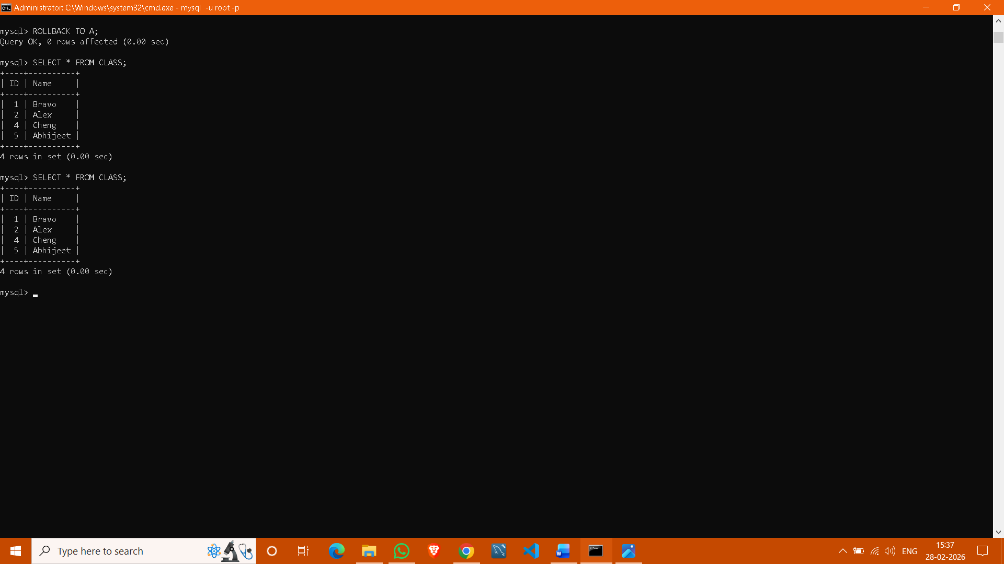

Part B: Retrieving Records (EMPLOYEES Table)

- Find out the employee id, names, and salaries of all the employees.
- List out the employees who work under manager 100.
- Find the names of the employees who have a salary greater than or equal to 4800.
- List out the employees whose last name is ‘AUSTIN’.
- Find the names of the employees who work in departments 60, 70, and 80.
- Display the unique Manager_Id.



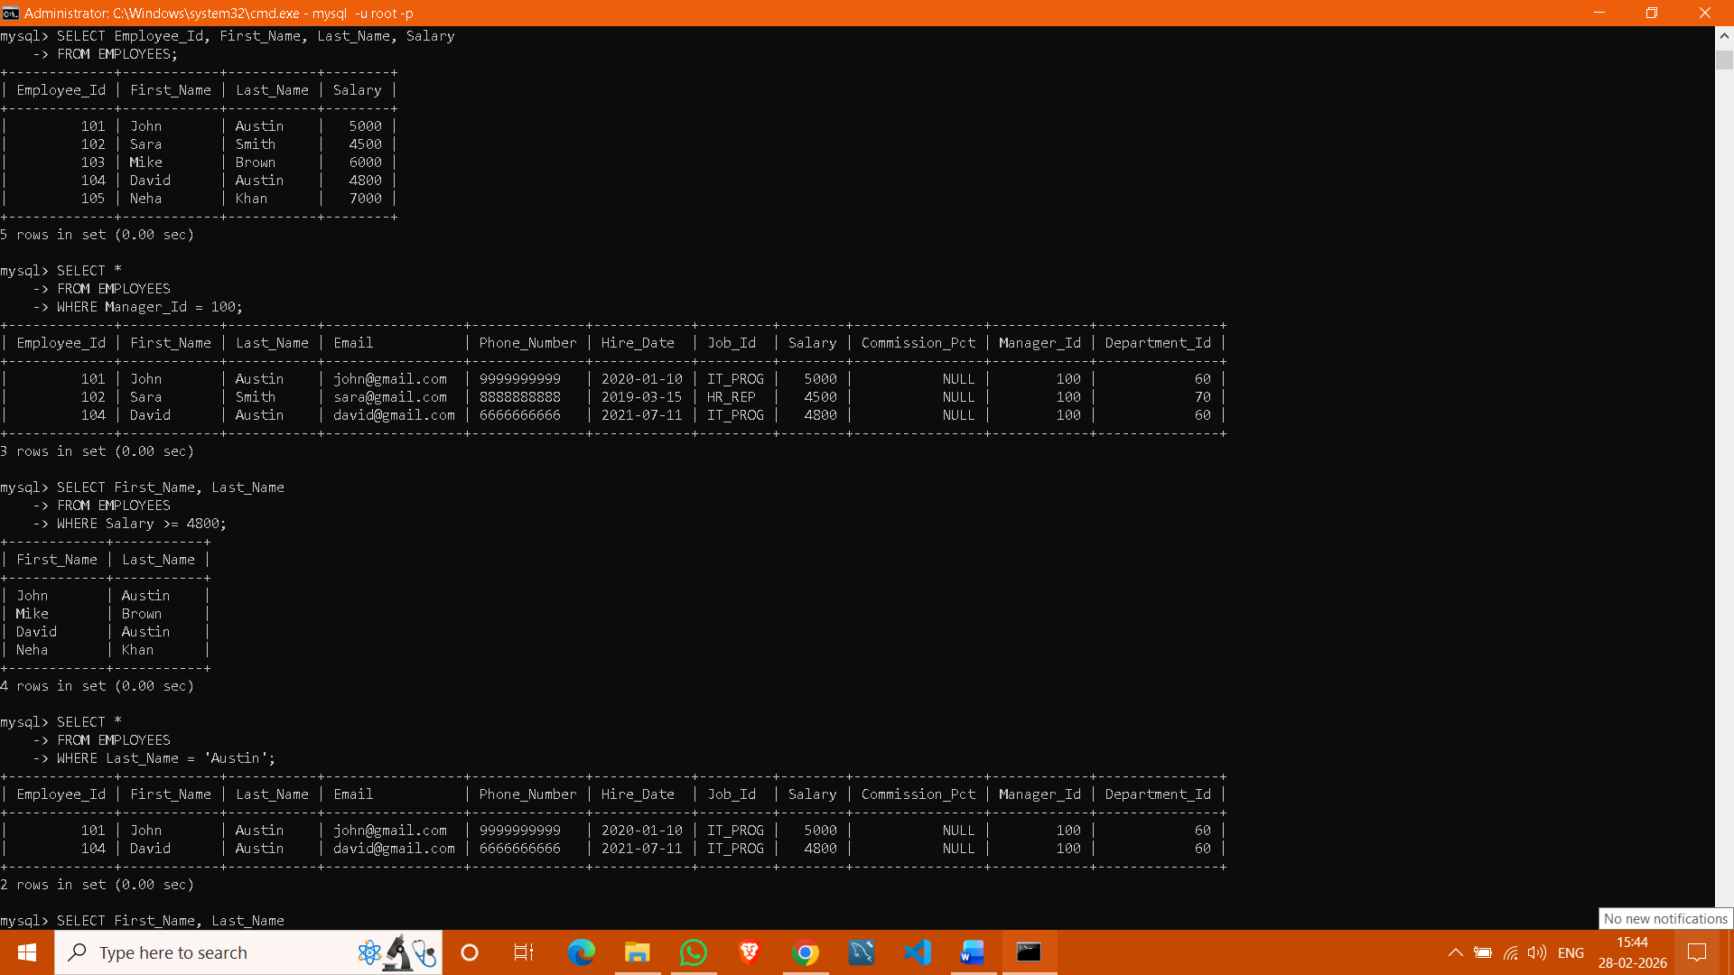

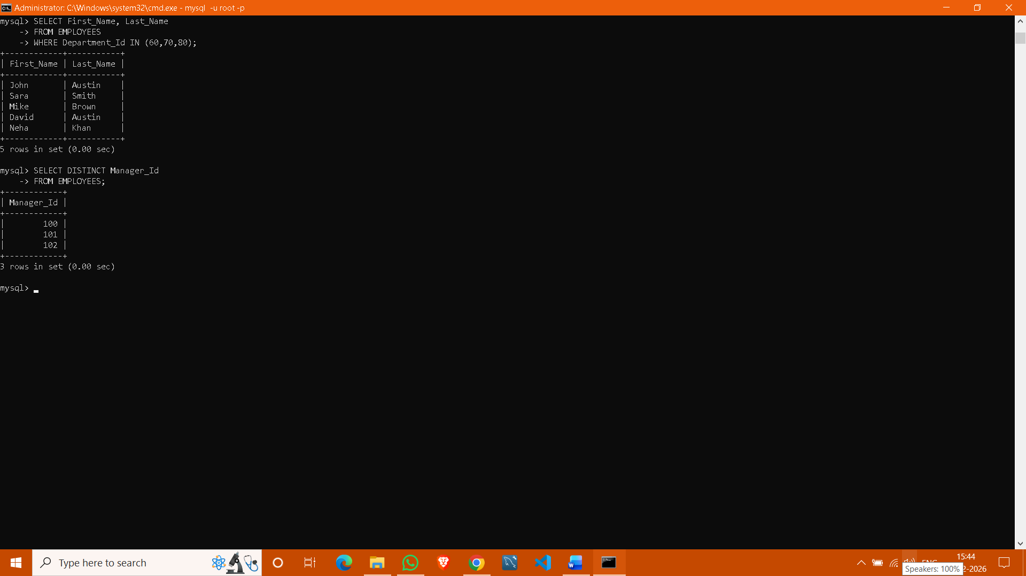

Part C: Updating Records (Client_master Table)
- Insert five records into the Client_master table.
- Find the names of clients whose bal_due > 5000.
- Change the bal_due of ClientNO "C123" to Rs. 5100



